CSCI-6461
Computer System Architecture
PROJECT 1 - Simulator

Designed by – TEAM 5
Avish Kaushik
Harichandana Samudrala

GITHUB URL - https://github.com/AvishKaushik/Simulator.git

Design Notes for the Simulator
1. Overview of the Project
The CSA Simulator is a tool that emulates the key components of a computer system architecture, including the CPU, memory, input/output devices, and conversion utilities. The system is implemented in Java with a graphical user interface (GUI) using Swing to provide users with interactive controls for simulating CPU operations, memory management, and device interaction.
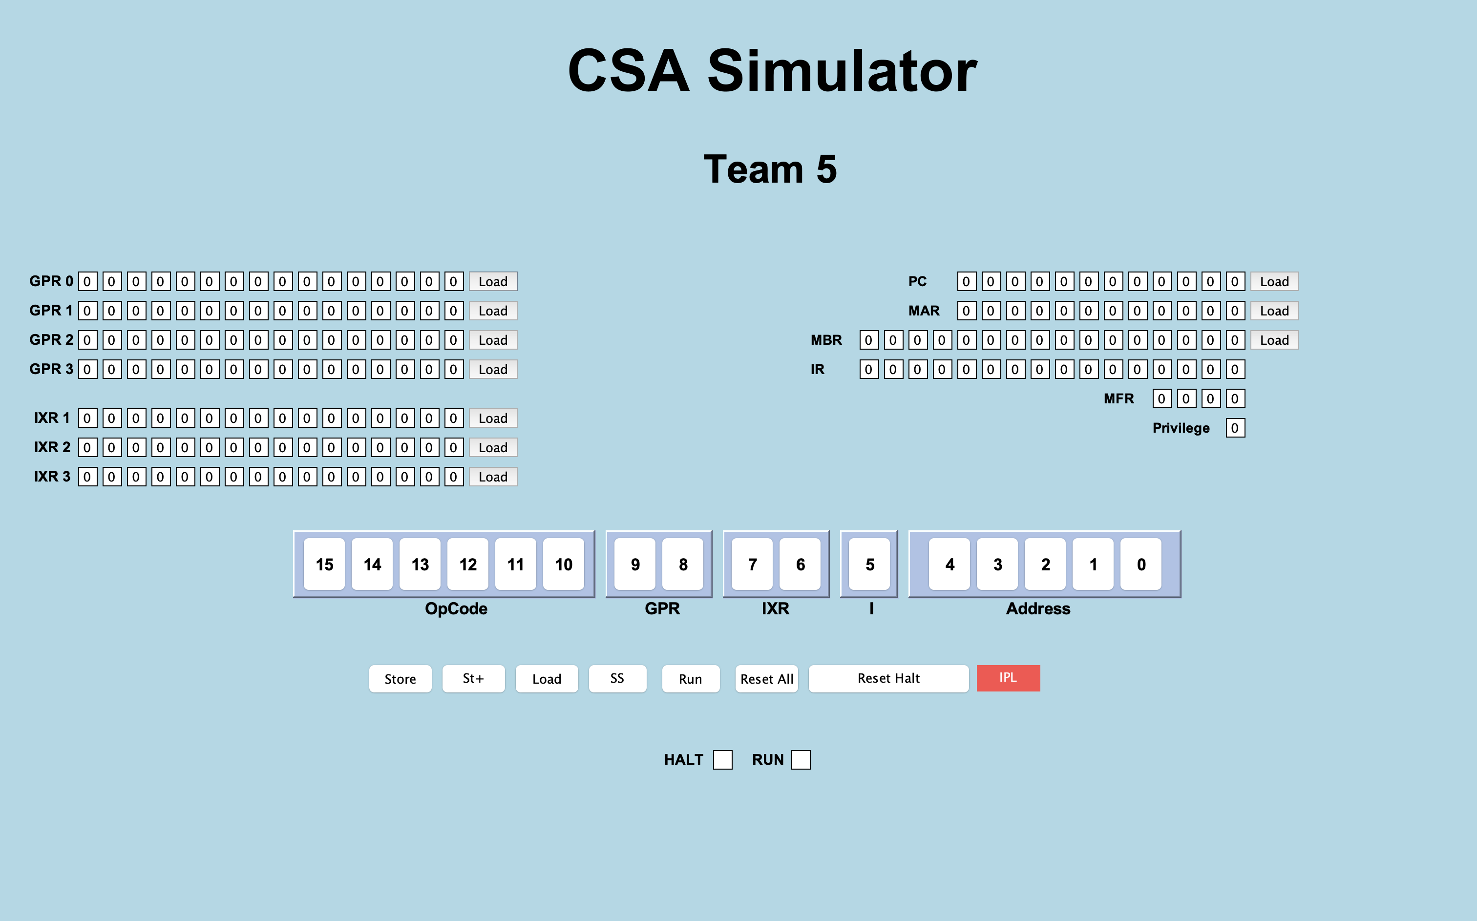

2. System Components
Graphical User Interface (GUI)
- Java Swing-based GUI: The GUI is created using Swing components such as JLabel and JButton to visually represent registers, memory, and control buttons.

- Key GUI Components:
  - Registers and Labels: General Purpose Registers (GPRs), Index Registers (IXRs), and the Machine Fault Register (MFR) are displayed using JLabel components.
  - Control Buttons: Buttons like "Store," "Load," "Reset," and "Run" allow users to interact with the system, controlling data storage, code execution, and system resets.
  - Event Handling: Each button has an associated event listener, which calls methods like Store(), LoadValue(), and RunProg() to execute corresponding actions.
- Threading for Responsiveness: The "Run" button uses a background SwingWorker thread to ensure the GUI remains responsive during long-running processes, such as executing a program.
- Fixed Layout: The GUI layout is manually set using setBounds() to position elements, resulting in a static layout. This could pose challenges for resizing or adapting to different screen resolutions.
Memory Management (Memory.java)
- 2KB Memory Array: The memory is simulated using a short[] array with a fixed size of 2048 cells (2KB). Each cell is initialized to zero at the start.
- Fixed Memory Size: The memory size is currently hardcoded, which may limit flexibility for future expansion. A constructor could be added to make the memory size configurable.
Devices Interface (Devices.java)
- Console Input/Output Simulation: The device interface mimics a console using JTextArea components:
  - ConsoleOut: A simulated console output (printer), styled with a monospaced font (Courier New) and a green-on-black color scheme.
  - ConsoleIn: A single-line input area representing the console keyboard.
  - Panels: Panels are used to organize the components, each with a titled border for clarity.
- Manual Layout: The device panels use setBounds() for manual positioning, making the GUI non-responsive to window resizing.
Number Conversion Utility (Converter.java)
- Binary, Decimal, and Hex Conversions: The Converter class provides utility functions to convert numbers between binary, decimal, and hexadecimal formats, a key feature for simulating CPU operations.
  - BinaryToDecimal(): Converts a binary array to its decimal equivalent.
  - DecimalToBinary(): Converts a decimal number to its binary representation.
  - HexToDecimal(): Converts a hexadecimal string to a decimal number.
- Reusability: These conversion functions are designed to be reusable across different parts of the system, particularly in the CPU and memory handling processes.
CPU Simulation (CPU.java)
- Register Management: The CPU class manages a set of registers, including General Purpose Registers (GPRs), the Program Counter (PC), Instruction Register (IR), and more.
- Instruction Execution: The Execute(Memory m) method processes instructions by decoding binary opcodes and executing corresponding operations, such as loading and storing data, halting the program, and addressing operations.
  - Opcode Handling: A switch-case structure is used to handle various opcodes like LDR (load register), STR (store register), and HLT (halt).
- Memory Fault Handling: The Memory Fault Register (MFR) detects and manages memory faults. If a fault occurs, the system resets the PC and stores the fault address in memory.
- Inheritance: The CPU class extends the Converter class, allowing direct access to number conversion methods, which are integral for interpreting opcodes and addressing information.

3. Key Design Considerations
- Manual Layout: The reliance on setBounds() for GUI positioning results in a static layout that may not scale well with different screen sizes. Refactoring to use layout managers like GridLayout or BorderLayout would enhance the flexibility of the interface.
- Threading for Long Operations: The use of SwingWorker to handle long-running operations in the background ensures that the GUI remains interactive while the system executes processes like the "Run" functionality.
- Memory Size Flexibility: The memory is currently fixed at 2KB, which could limit future scalability. Implementing a dynamic memory allocation system or configurable memory size could provide greater flexibility in the simulator.
- Reusability of Conversion Utilities: The Converter class methods for binary, decimal, and hex conversions are decoupled from the specific CPU or memory logic, making them highly reusable across the system.

4. Project Structure

- src/main/java: Contains the main source code for the project.
  - com.csa.simulator.components: Contains various components of the simulator, including:
    - Converter: Likely handles conversion operations or data types.
    - CPU: Manages CPU-related functionality.
    - Devices: Manages connected devices or I/O operations.
    - Memory: Handles memory management for the simulator.
  - com.csa.simulator.gui: Contains classes related to the graphical user interface (GUI).
    - GUI: The main class for the user interface components.
    - Main: Likely the main entry point of the application.
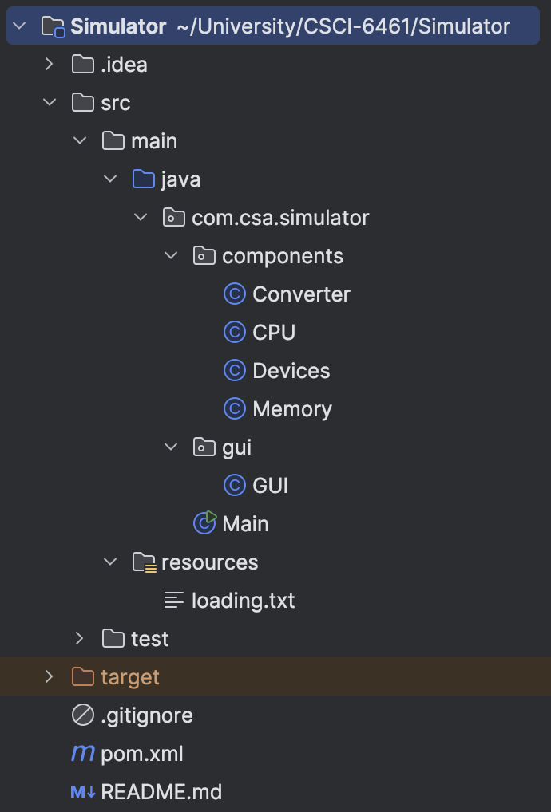
- src/main/resources: Contains non-code resources like configuration files.
  - loading.txt: Likely used during application loading or initialization.
- src/test: (Currently empty in the image) Reserved for test cases and unit tests.
- target: (Generated by Maven) Holds the compiled bytecode and packaged outputs (e.g., JAR files).
- pom.xml: The Maven Project Object Model file, used for managing project dependencies and build configurations.
- README.md: Documentation file providing an overview of the project and setup instructions.
- .gitignore: Specifies files to be ignored by Git version control (e.g., compiled binaries or temporary files).

